**Ideation Phase**

**Define the Problem Statements**

|  |  |
| --- | --- |
| Date | 21 OCTOBER 2022 |
| Team ID | PNT2022TMID03634 |
| Project Name | Project - Smart Waste Management For Metropolitan Cities |
| Maximum Marks | 2 Marks |

**Customer Problem Statement Template:**

To comprehend the viewpoint of your customer, write an issue statement. In order to build experiences that customers will appreciate, the Customer Problem Statement template can help you concentrate on what important.

You and your team can identify the appropriate solution to the problems your clients are facing with the help of a clearly stated customer problem statement.

Throughout the process, you’ll also be able to empathize with your customers, which helps you better understand how they perceive your product or service.

Reference: <https://miro.com/templates/customer-problem-statement/>

**Example:**

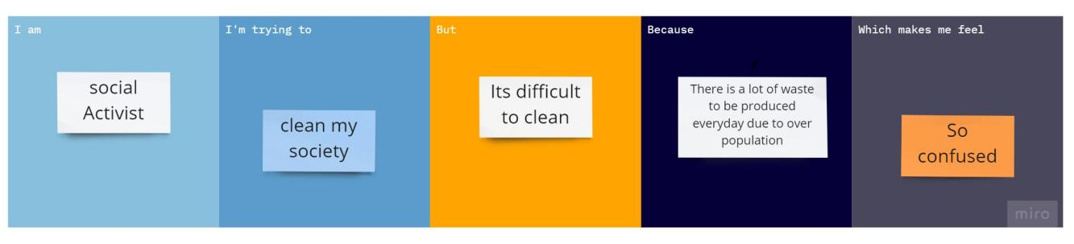

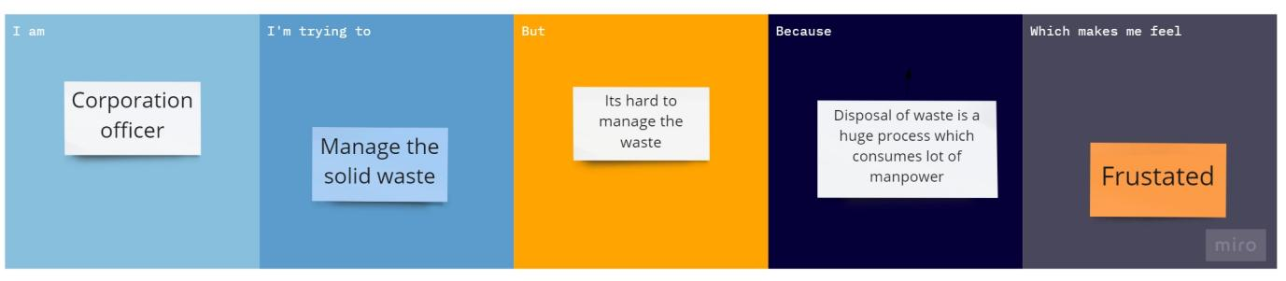

|  |  |  |  |  |  |
| --- | --- | --- | --- | --- | --- |
| **Problem Statement (PS)** | **I am (Customer)** | **I’m trying to** | **But** | **Because** | **Which makes me feel** |
| PS-1 | Social activist | Clean my society | Its difficult to clean | There is lot of waste to be produced everyday due to overpopulation | So confused |
| PS-2 | Corporation Officer | Manage the solid waste | Its hard to manage the daily waste | Disposal of waste is a huge process which also consumes lot of manpower | frustated |